***Experiment 7***

**Aim:** Continuous Integration Setup: Set up a basic continuous integration (CI) pipeline using tools like GitHub Actions or Travis CI to automatically build and test code changes on every commit.

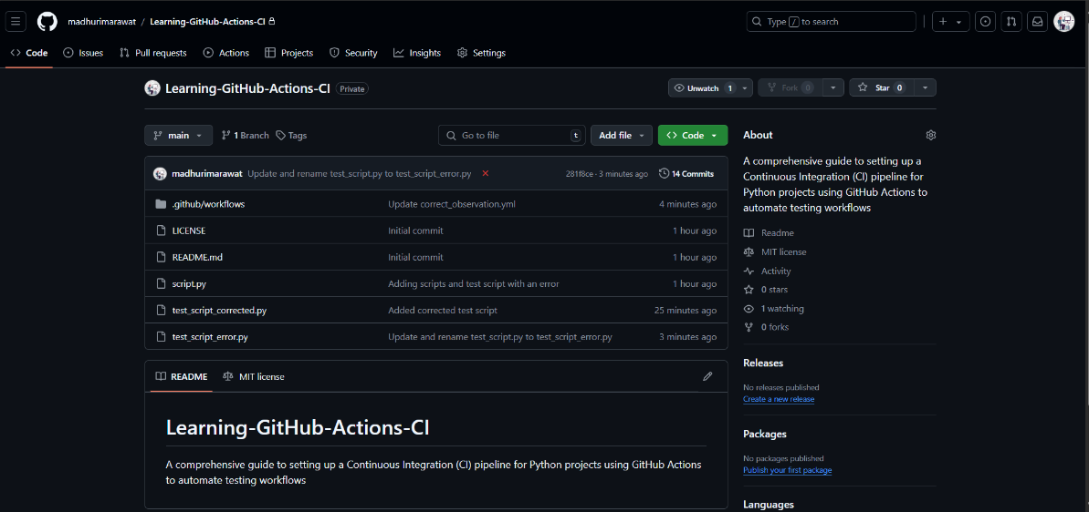**GitHub Actions:** Automating Python Testing with GitHub Actions

***Fig 1: Running Sphinx Commands***

***Fig 2: Output Sphinx Documentation***

**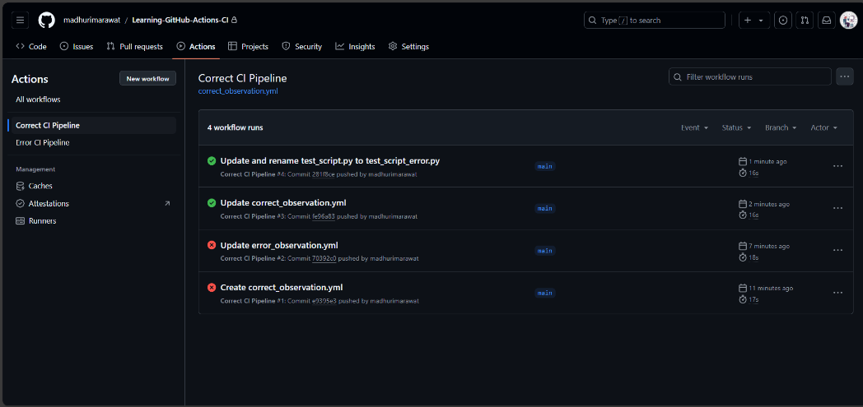*Fig 1: GitHub Repository with all the Files and Workflows***

***Fig 2: Outp***

**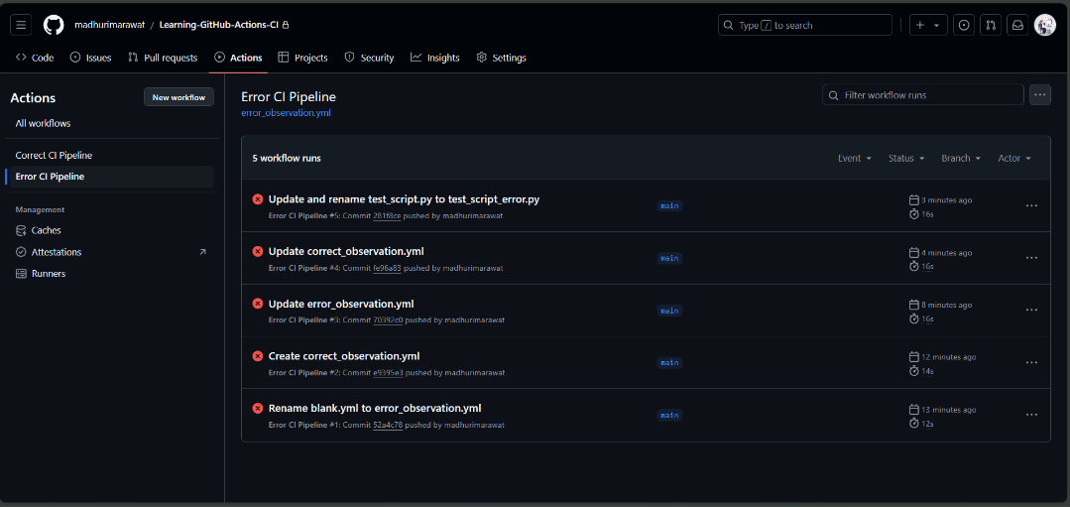*Fig 2: GitHub Repository with Correct Workflows(Successful Test Cases)***

***Fig 3: GitHub Repository with Error Workflows(Wrong Test Cases to observe workflow)***